**NATIONAL EGG QUALITY SCHOOL APPLICATION**

**Embassy Suites Resort & Conference Center**

**Greenville, SC**

**MAY 19 to 22, 2025**

*Please type or print*

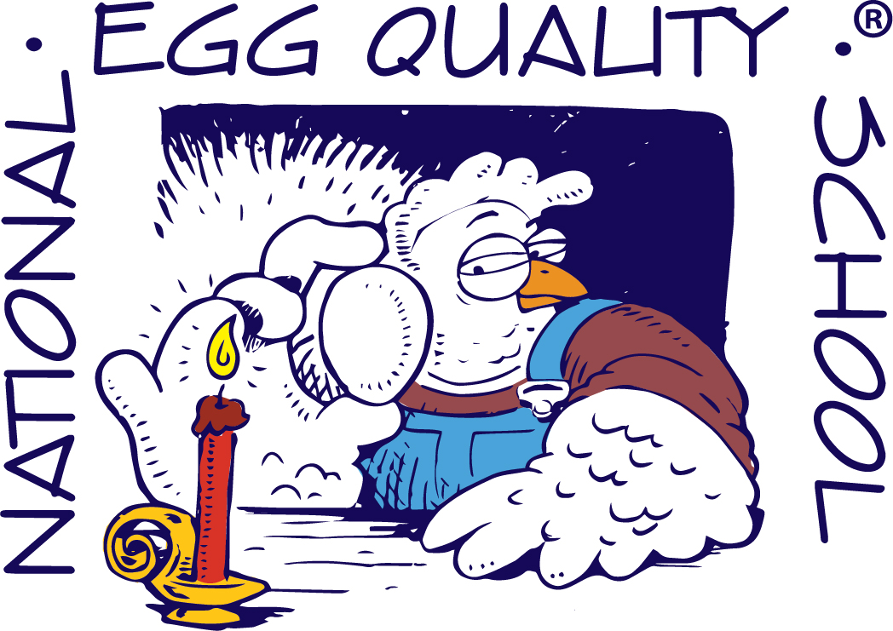

Applicant Name

Company, organization, or farm connection

Address

City, State, and Zip Code

     

Phone Number Email

Registration fee for tuition and meals:

**Prior to April 1 $600 Academia & Government**

**$700 all Others**

**After April 1 $700 Academia & Government**

**$800 all Others**

**I would like to receive an electronic version of the National Egg Quality School Handbook.**

Mail application to:

**CDFA-MPES**

**Attn: Penny Arana – National Egg Quality School**

**1220 N Street, Suite 342**

**Sacramento, CA 95814**

Application must accompany a check for tuition and meals payable to the **National Egg Quality School**. If cancellation is received by April 1, 2025, a refund will be issued. If payment was made with PayPal, the processing fee will be withheld when issuing a refund.

**ENROLLMENT DEADLINE: APRIL 1, 2025**

I understand the rate charged per person by Embassy Suites will be $164.00 single or $164.00 double plus tax per night. Group reservations for lodging will be made by the school for all rooms and room payment is payable individually to the hotel, by the student. All rooms are non-smoking.

Please reserve:  Single Room  Double Room

If double, name of person with whom I am rooming

     

Arrival Date Departure Date